PRODUCT BULLETIN
MODEL V-HD DOUBLE SUCTION

PRODUCT BULLETIN MUNICIPAL COMMERCIAL INDUSTRIAL
MODEL V-HD DOUBLE SUCTION Quench Water, Filtration, Transfer, HVAC, Booster, Process, Petrochemical
Filter Backwash, Supply Water Supply Water, Reverse Osmosis
Bulletin 340V-HD
Edition 1

Vertical Heavy Duty Spit Case

American-Marsh Model V-HD Vertical Double Suction pumps are used in a variety of industries. These rugged and efficient centrifugal pumps are designed for long life and low operational costs. Each model has a removable rotating assembly that can be serviced without disturbing the driver or piping. Models are available in a packed or mechanically sealed orientation for use in demanding applications. All models feature a fully casted pump and motor base.

Material Specifications
PART | CONSTRUCTION
PART | BRONZE FITTED | IRON FITTED | 316SS FITTED
Casing | Cast Iron | Cast Iron | Cast Iron
Impeller | Bronze | Cast Iron | 316 Stainless Steel
Shaft Sleeve | Bronze | Bronze | 316 Stainless Steel
Stuffing Box | Cast Iron | Cast Iron | Cast Iron
Shaft | 420 Stainless Steel | 420 Stainless Steel | 410 Stainless Steel
Case Wear Ring | Bronze | Cast Iron | 316 Stainless Steel
Packing | Graphite Braid | Graphite Braid | Graphite Braid
Mechanical Seal | Carbon/Si-C/Buna | Carbon/Si-C/Buna | Carbon/Si-C/Buna
MODEL V-HD SPECIFICATIONS

Casing: The casing is of high tensile cast iron or other specified material. It is of the volute type with double suction, split on the horizontal centerline with the suction and discharge nozzles cast integral with the lower half. Suction and discharge nozzles are casted of 250 psi dimensions and all models feature a 250 psi case working pressure. Removal of the upper casing gives complete access to the interior of the pump without disturbing piping connections or pump alignment. The casing utilizes Thru-Bore lineboring technology simplifying the machining operation and allows the advantage of using only a few modular rotating assemblies. The Thru-Bore feature allows for the complete removal and replacement of the stuffing boxes without replacing the casing.

Impeller: The impeller is of the double suction, enclosed, non-overloading type. It is made of bronze, or other specified material, machined and polished all over and dynamically and hydraulically balanced. The impeller is keyed to the shaft and secured by locknuts. It is adjustable for position.

Case Wear Rings: Case wear rings are made of bronze or other specified material. They are designed with a large wearing surface with the diameter at wearing surface reduced to a minimum, and are firmly secured in the casing by dowel pins.

Shaft: The shaft is of 420 stainless steel, ground and polished to a smooth surface. It is designed for extra stiffness to avoid all critical speeds in operation, and is threaded for bearing and impeller lock nuts. The portion of the shaft that is exposed to the pumped fluid is covered with renewable bronze shaft sleeves screwed on against the impeller with right and left hand threads which cannot work loose during operation. Shaft sleeves have external o-rings, in lieu of internal o-rings, to stop leakage of product.

Stuffing Boxes/Seal Chambers: The stuffing boxes/seal chambers are extra deep, being designed for packing and lantern ring or mechanical seals. Under each stuffing box is a drip pocket with tapped drain outlet. The stuffing boxes/seal chambers are completely removable and replaceable.

Bearings: Both the inboard and outboard ball bearings are of the single row, deep groove type, precision grade, with cartridge mounting, permitting the removal of the shaft without exposing or disturbing the bearing assembly. They are of extra large capacity for both radial and thrust loads. The outboard bearing is confined rigidly in the bearing housing to take end thrust, while the inboard bearing is set with sufficient clearance to allow for shaft expansion. All bearings are sized to maintain a minimum of 50,000 hour bearing life. Each bearing is designed for grease lubrication and is provided with a water slinger to prevent leakage from the stuffing box into the bearing. A zerk fitting is furnished for each bearing. Each bearing housing is sealed from water leakage by the use of an oil lip seal.

Both bearings can be removed and replaced without removing the rotating assembly from the pump, greatly simplifying the repair process.
Bulletin 340V-HD
Edition 1

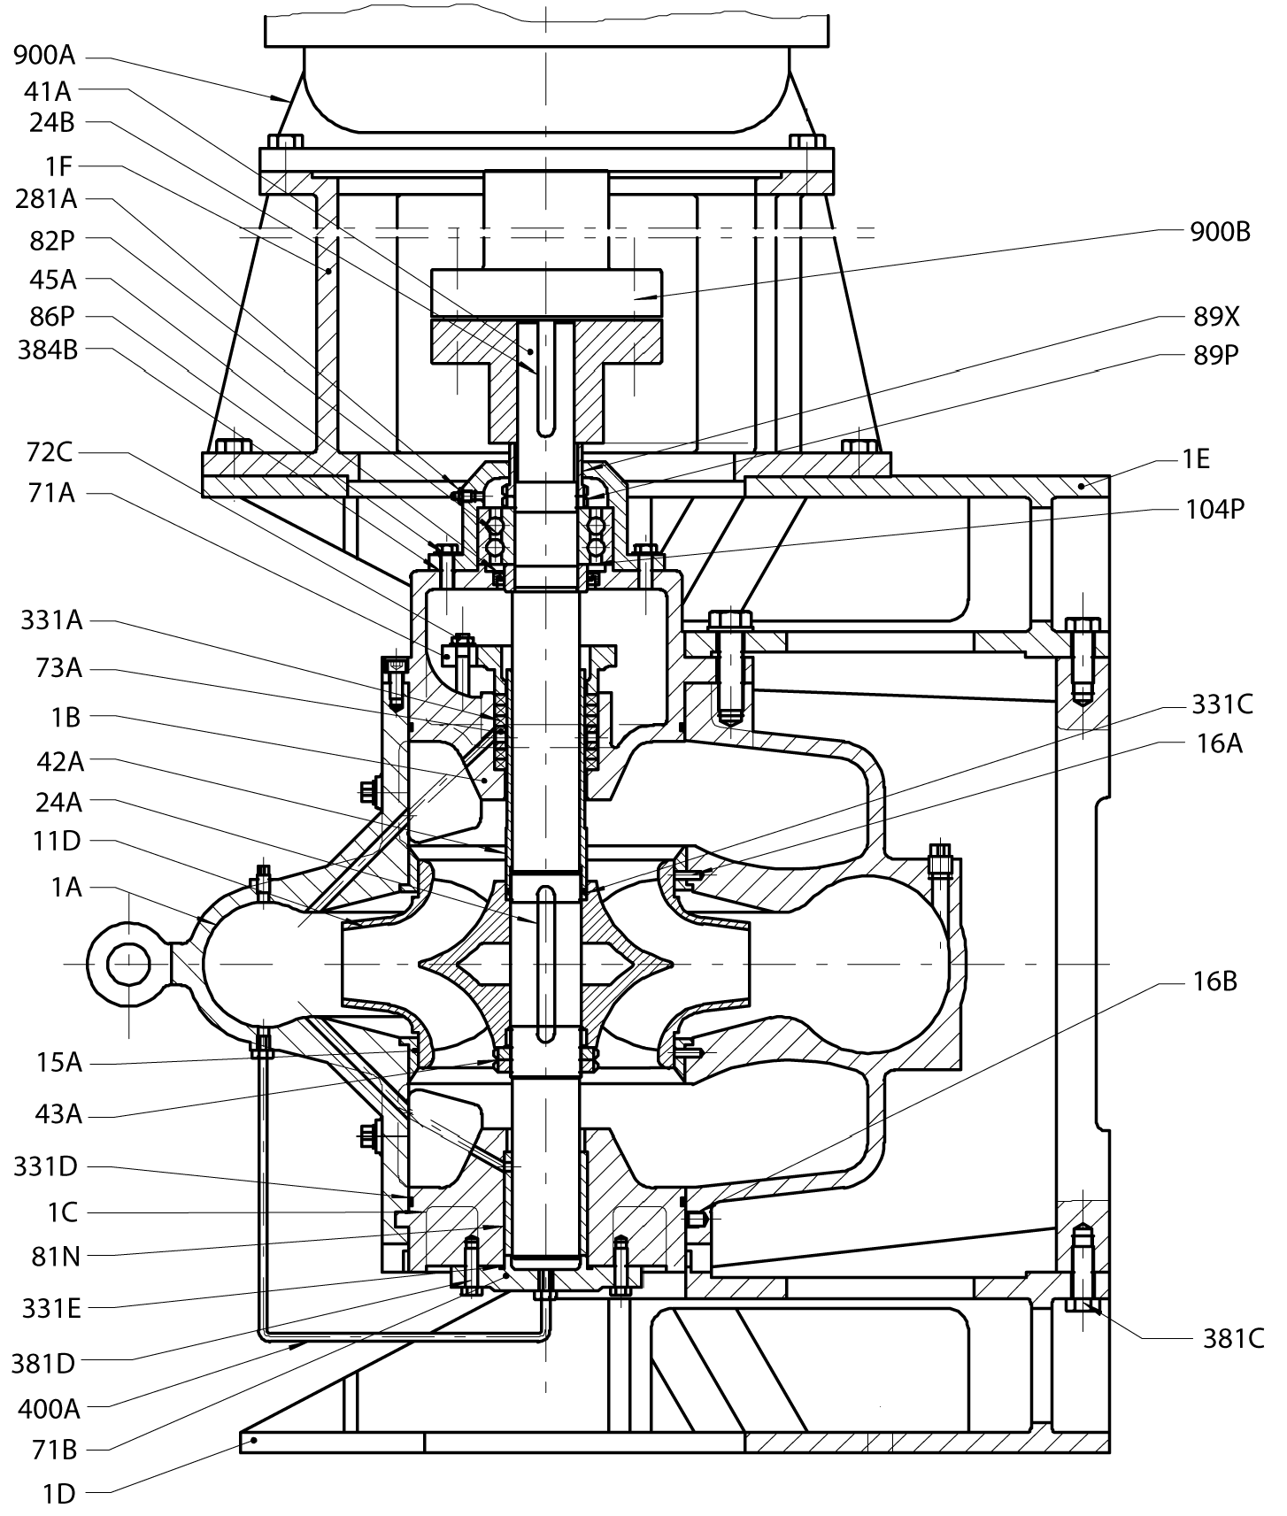
V-HD Sectional Drawing

Item Number | Item Description | Num. Req. |  | Item Number | Item Description | Num. Req.
1A | Casing, Complete | 1 |  | 86N | Bearing Housing Cap | 1
1B | Stuffing Box, Inboard | 1 |  | 86P | Bearing Housing, Inboard | 1
1C | Stuffing Box, Outboard | 1 |  | 89P | Locknut, Inboard | 1
1D | Casing Bottom Base | 1 |  | 89X | Locknut, Inboard | 1
1E | Casing Top Base | 1 |  | 104P | Lip Seal, Inboard | 1
1F | Motor Bracket | 1 |  | 281A | Zerk Fitting | 2
11D | Impeller | 1 |  | 331A | Packing | 1 Set
15A | Case Wear Ring | 2 |  | 331B | Mechanical Seal (Optional) | 1
16A | Dowel Pin | 2 |  | 331C | Shaft Sleeve O-Ring | 1
16B | Dowel Pin | 2 |  | 331D | Stuffing Box O-Ring | 2
24A | Impeller Key | 1 |  | 331E | Gland Plate Gasket, Outboard | 1
24B | Coupling Key | 1 |  | 353A* | Case Gasket | 1
41A | Shaft | 1 |  | 384B | Bearing Housing Capscrews | 8
42A | Shaft Sleeve | 1 |  | 381B* | Casing Capscrew | Varies
43A | Shaft Sleeve Locknut | 2 |  | 381C | Capscrew, Base | Varies
45A | Bearing Adapter | 2 |  | 381D | Capscrew, Gland Plate | Varies
71A | Gland Assembly, Complete, Inboard | 1 |  | 400A | External Flush Line | 1
71B | Gland Plate, Outboard | 1 |  | 411A | Plug, Vent | 1
72C | Gland Stub | 4 |  | 411B | Plug, Drain | 1
73A | Lantern Ring | 2 |  | 411D | Plug, Bearing Housing | 1
81P | Inboard Bearing, Radial/Thrust | 1 |  | 900A | Motor | 1
81N | Outboard Bearing, Radial | 1 |  | 900B | Motor Coupling | 1
82P | Bearing Housing, Inboard | 1
* Not shown in sectional.
Recommended spare parts are in BOLD.

